en00388_

en00388_

en00388_

**Friday 9**

**November 2012**

**en00388_en00388_**

**ALL WELCOME!**

* 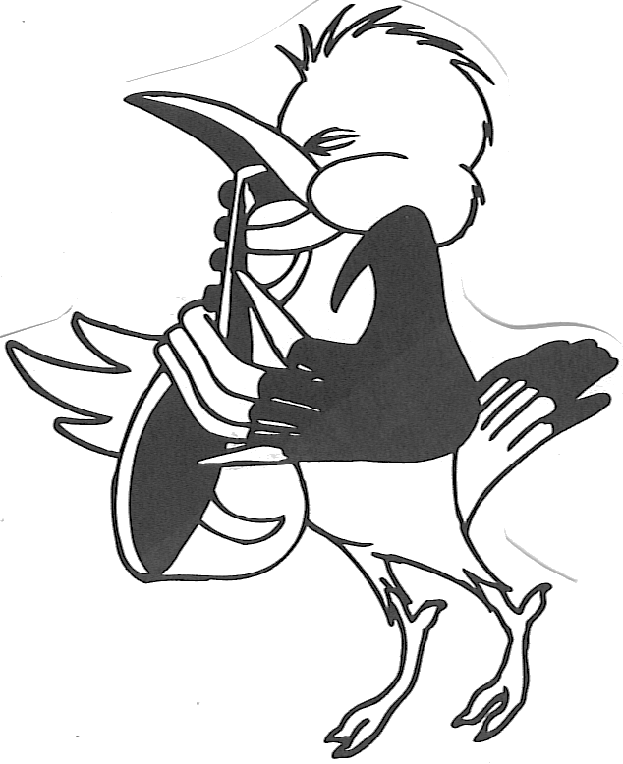**6:00pm – all performing students**

en00388_**to arrive at A.V.room**

* **6:30pm – 7:00pm**

**Pasta & Pizza available for purchase**

* **6:50pm – Kegworth Assembly Hall doors open for audience entry (food or drink is not permitted in hall)**
* **7:00pm – Concert begins**
* **9:00pm – Concert conclusion – cake & drinks available as per ticket purchase**

**Ticket Prices:**

* + - * **$20:00 per family OR $8:00 per adult & $5:00 per child.**
      * **All performers free.**
      * **Ticket prices include softdrink, water, coffee or tea & cake**

**Tickets available for purchase in the playground or at the door**

**For more information – please contact Kegworth Public School ph: 9569 7320**